CHAPTER 1
CHAPTER TITLE
  - Section
    - Subsection
The text size should be 12 in times new roman. Figures should be centre justified with proper figure number. Equations should be numbered and should be typed using equation editor option of the Microsoft word. Finally, all the tables should be numbered and table description should be done above the table.
(Examples for image, table and equations given below)
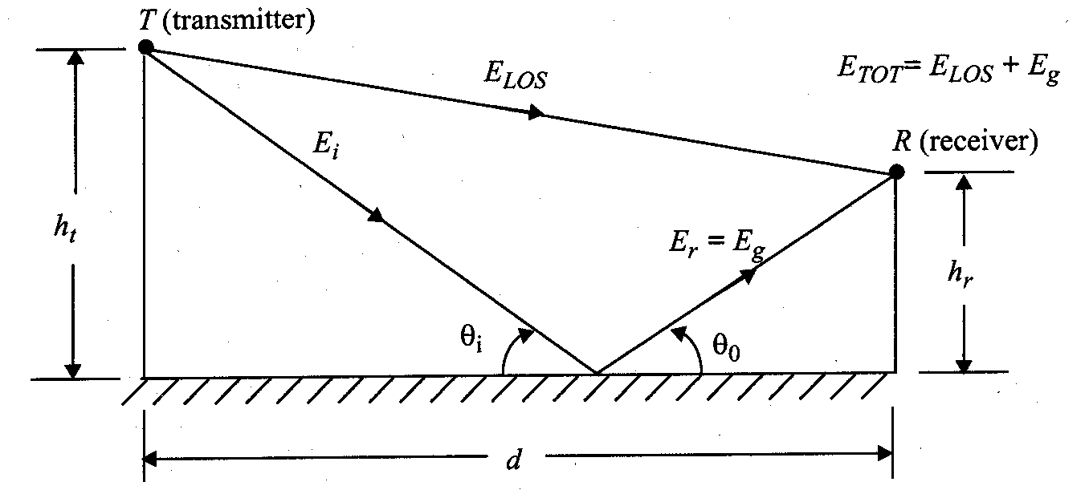
Figure 1.1: Two Ray Model

Table 1.1: Table Description
XYZ | X | Y | Z | S
1
2
3
4

S_{δ}(f )= F[s_{δ}(t)] = f_{s} 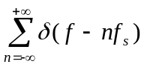 (1.1)

Mini-Project Report Format for Second Year Students
The organization of the report should be as follows:
- Cover Page & Title Page
- Certificate
- Acknowledgement
- Abstract not exceeding 100 words
- Table of Contents
- List of Tables – if any
- List of Figures – if any
- Chapter 1-Introduction (Overview, Motivation, Scope of the work, Objective)
- Chapter 2- System Requirements
- a) Hardware Requirements
- b) Software Requirements
- Chapter 3- Design/Implementation
- Chapter 4- Testing/Result and Analysis
- Chapter 5- Conclusions & future enhancements
- References- in standard IEEE format
Note: 1. Printing: on A4 size paper with 1.5 line spacing
2. Margins: Left-1.25”, Right- 1”, Top and Bottom-0.75”
3. Font Style: Times New Roman
4. Font Sizes: Title of the chapter (14), sections (14), subsections (12) and the text (12).
5. All equations, figures, and tables should be numbered
6. Spiral binding should be used for the report

Title Page

(Title of the Project)
A
Report submitted in partial fulfillment
Of
the requirement for the degree
of
B.Tech.
In

Computer Science & Engineering
Under the Supervision of

(Supervisor Name with Designation)
By

Student Name (Roll No)

Pranveer Singh Institute of Technology, Kanpur
Dr A P J A K Technical University
Lucknow

(Example of Certificate)

Certificate

This is to certify that Project Report entitled “………(Project Title)...................................
................................................................” which is submitted by …(Student Name)…
in partial fulfillment of the requirement for the award of degree B. Tech. in Department of

Computer Science and Engineering of Pranveer Singh Institute of Technology, affiliated to Dr. A.P.J. Abdul Kalam Technical University, Lucknow is a record of the candidates own work carried out by them under my/our supervision. The project embodies result of original work and studies carried out by the students themselves and the contents of the project do not form the basis for the award of any other degree to the candidate or to anybody else.

Signature:  Dr. Vishal Nagar  Head of Department  CSE Department,  PSIT, Kanpur |  | Signature:  (Name of Supervisor)  Designation  CSE Department,  PSIT, Kanpur

Date:

(Example of Declaration)

DECLARATION

We hereby declare that this submission is our own work and that, to the best of my knowledge and belief, it contains no material previously published or written by another person nor material which to a substantial extent has been accepted for the award of any other degree or diploma of the university or other institute of higher learning, except where due acknowledgment has been made in the text.

Signature

Name:

Roll No.:

Date:

(Sample of Acknowledgement)

ACKNOWLEDGEMENT

It gives us a great sense of pleasure to present the report of the B.Tech. Project undertaken during B.Tech. Final Year. We owe special debt of gratitude to our project supervisor ……. (Name of Supervisor) ……………………………, Department of Computer Science and Engineering, Pranveer Singh Institute of Technology, Kanpur for his constant support and guidance throughout the course of our work. His sincerely, thoroughness and perseverance have been a constant source of inspiration for us. It is only his cognizant efforts that our endeavors have seen light of the day.

We also take the opportunity to acknowledge the contribution of Professor Dr. Vishal Nagar, Head, Department of Computer Science & Engineering, Pranveer Singh Institute of Technology, Kanpur for his full support and assistance during the development of the project.

We also do not like to miss the opportunity to acknowledge the contribution of all faculty members of the department for their kind assistance and cooperation during the development of our project. Last but not the least, we acknowledge our friends for their contribution in the completion of the project.

Signature

Name:

Roll No.:

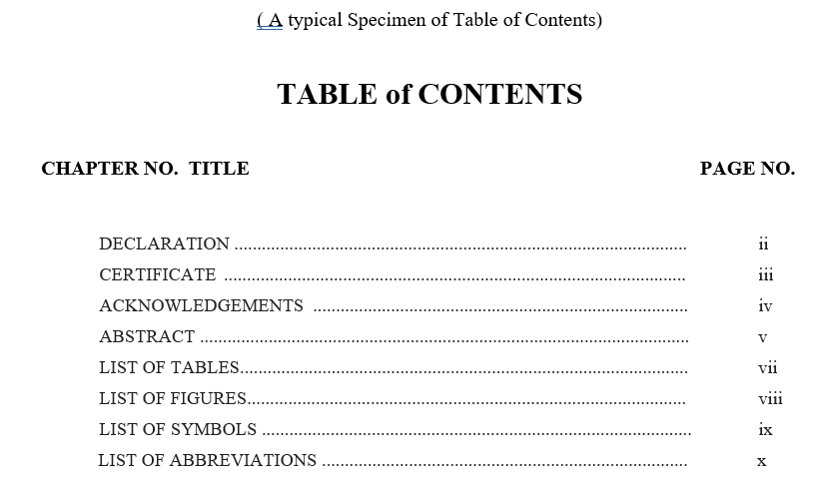

Main Content Indexing Sample:
1.1 MOTIVATION 1
  - BACKGROUND OF PROBLEM 2
    - Current System 12
    - Issues in Current System 15
      - Functionality Issues 17
      - Security Issues 21

